Create New Visitor
How to create a visitor?
- Click on “New Visitor” icon(Create).
- Fill required fields one by on
    - Visitor ID no is compulsory (Here you can use National ID No, Driving License No & Passport No.).
    - If you have a photo of the visitor you can upload it. Its size must be less-than 100Kb.
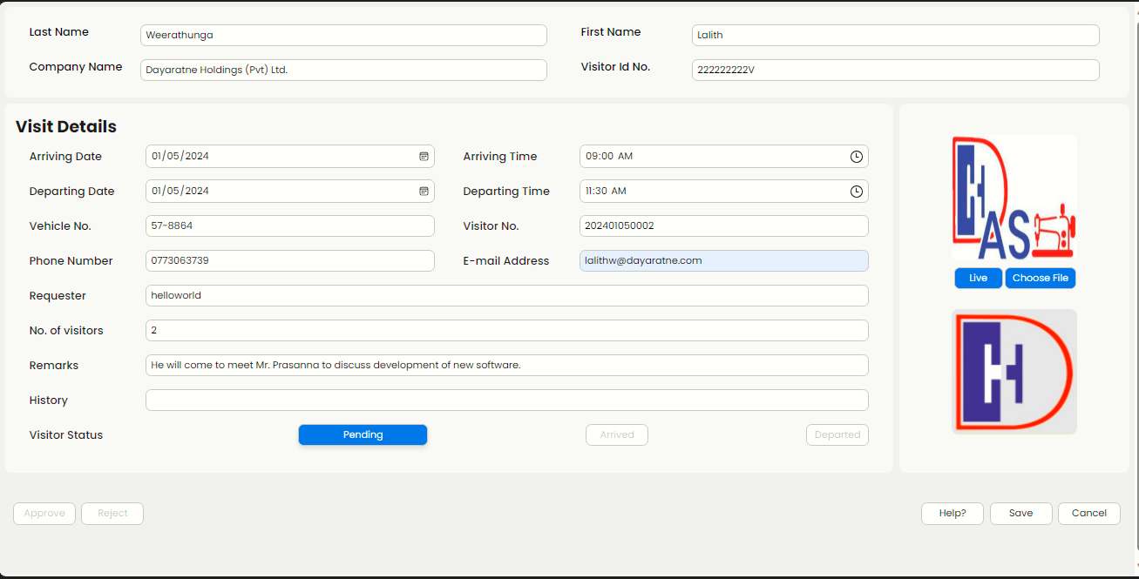
- The final form like given below.
- If information are correct, Click on “Save”.
- If you do not need to save Click on “Cancel”.

Approve Visitor
How to Approve a visitor?
- Click on “Approve Visitor” icon “→”.
(Requester cannot approve his own request).
- Click on the relevant visitor number on side panel.
- If any information need to update, mention in Remarks Field as required.
- If enough information are there, Click on “Approve”, else Click on “Reject”.

Password Change
How to change current user's password?
- Click on “Change” icon.
- Type new password in both text boxes.
- Click on “Save”.

User Management
How to create a new user?
- Click on “Manage” icon.
- To create a new user Click on “Create” icon.
- Fill all fields with relevant information.
- Select User level.
- Admin – Can do any changes except Gate users functions.
- Approver - Can Approve & Create a new visitor Request.
- Requester – Only do request for a new user.
- Gate – Only Arrive & Departure functions are allowed.
- Click on “Register”
How to update an existing user's information?
- Click on relevant user record.
- Change information as required.
- Click on “Save”
How to delete a user login?
- Type the user name in search box, then Click on “Search” icon or Click on the Check box of the relevant users which is located at the left side of the user name.
- Click on “Delete” icon.
- *By clicking on “Select all” check box you can delete all users at once.
- By Clicking on “←” icon on left upper corner, you can come back to your dashboard.

Reports
How to generate Reports?
- Click on Reports “→” icon.
- Select required report on side panel.
I. User report – Generate users list.,
ii. Visitor Reports – Generate visitors list.(You should select a starting date & ending date for the report.)
- Finally Click on “Export” to generate the excel sheet.

Gate User
How to visitor entrance manage?
Visitor Entrance
- When a visitor arrives, ask the visitor number.
- Click on Arrive Visitor “→” icon.
- Click on the relevant visitor number.
- Check the Visitor ID number.
- If any information mismatch except Visitor ID number, update the Remarks Field as required.
- Click on “Arrived”
When Visitor Departure
- When a visitor depart, ask the visitor number.
- Click on Departure Visitor “→” icon.
- Click on the relevant visitor number.
- Click on “Departed”

